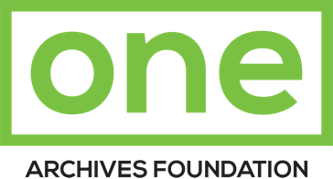

909 West Adams Boulevard, Los Angeles, CA 90007 | 213.821.2771 | askone@usc.edu | one.usc.edu

Deed of Gift

Name of Collection: | Accession Number:
Donor of Collection: (Date of Birth: ________ ) | Contact Person (if different please complete below*):
Street Address: | *Street Address:
City, State, and Zip: | *City, State, and Zip:
Telephone/E-mail: ⃝ Mobile ⃝ Home ⃝Work | *Telephone/*E-mail: ⃝ Mobile ⃝ Home ⃝Work
The donation has been received by the Archives as a gift, and the owner or his agent with full authority, desiring to absolutely transfer full title and all copyrights to the Archives by signing below, hereby gives, assigns, and conveys finally and completely, and without any limitation or reservation, the property, including all rights whether conferred by law, statue or equity, described below to the Archives and its successors. The Archives reserves the right to dispose of or transfer materials which will not be maintained in the permanent collection.

Description of Donation:
Credit Line:
Signatures:

Donor: ___________________________________________________________________

Printed Name: _____________________________________________________________ Date: ________________

ONE Representative: ________________________________________________________ Date: ________________

Conditions Governing Gifts

- It is understood that all gifts are outright and unconditional unless otherwise noted upon this gift agreement
- Gifts to the Archives may be deductible in accordance with provisions of federal income tax laws.
- The donor name on this form has not received any goods or services from the Archives in return for this gift.
- The staff of the Archives is not permitted to furnish appraisals.
- The Archives gratefully acknowledges your gift.
- Please indicate on the form beside “CREDIT LINE” how you would like to be acknowledged in any news releases, exhibition labels, or other publicity regarding this donation.

(This form may be a multipart form.) Version III 7/21/2016

